Chapter 1: Introduction to Pradhan Mantri Matru Vandana Yojana (PMMVY)
  - Objectives and scope of PMMVY
The Government of India has been implementing the Pradhan Mantri Matru Vandana Yojana (PMMVY) since 1st January 2017. The scheme is implemented as per provisions under Section 4 of the National Food Security Act (NFSA), 2013 which provides for financial support for pregnant and lactating mothers to improve the health and nutrition status of both mother and child, as well as to provide partial compensation for wage loss, if any, during pregnancy and after child birth.
PMMVY - Scheme Overview – link - https://www.youtube.com/watch?v=119B2eVz0BI&list=PLcE8_LFPUizgwNZHQC72TzQMvAly2Q5MA&index=6
  - Linkages with nutrition, health, and social protection outcomes
The objectives of the PMMVY are to provide cash incentive for partial compensation of wage loss, enabling the woman to take adequate rest before and after the delivery of the first child, and to promote improved health-seeking behaviour among Pregnant Women & Lactating Mothers (PW&LM).

The scheme primarily targets women belonging to socially, economically disadvantaged, and marginalized sections of society. Additionally, PMMVY 2.0 seeks to promote positive behavioural change towards the girl child by providing an additional cash incentive for the second child, if that is a girl.

  - Eligibility criteria (beneficiaries, parity, exclusions)
    - 5 videos including testimonials on MWCD YouTube channel (link)
To be eligible for PMMVY scheme, the age of beneficiary should be between 18 years & 7 months and less than 55 years at the time of child birth.
Mandatory requirements:
- Date of Birth of the beneficiary
- Aadhaar authentication of the beneficiary
- Beneficiary’s bank account must be Aadhaar seeded and DBT Enabled
- Mobile number
Eligibility criteria of beneficiary:
- Women belonging to Scheduled Castes and Scheduled Tribes
- Women who are partially (40%) or fully disabled (Divyang Jan)
- Women holder of BPL Ration Card
- Women Beneficiaries under Pradhan Mantri Jan Aarogya Yojana (PMJAY) under Ayushman Bharat
- Women holding e-Shram card
- Women farmers who are beneficiaries under PM Kisan Samman Nidhi
- Women holding MGNREGA Job Card
- Women whose net family income is less than Rs. 8 Lakh per annum
- Pregnant and Lactating AWWs/ AWHs/ ASHAs
- Women holding Ration Card under NFSA Act 2013
- Any other category as may be prescribed by the Central Government

Exclusion Criteria
All pregnant women and lactating mothers who are in regular employment with the Central Government or State Government or Public Sector Undertakings or who are in receiving similar benefits under any law, are not eligible to receive benefits under PMMVY.
To successfully complete the registration form, it is mandatory to enter the identity number for the selected eligibility document, and upload the corresponding document.
The beneficiary is eligible for registration in the PMMVY soft MIS within 270 days after childbirth or within 570 days from the Last Menstrual Period (LMP) date.
Childbirth cannot occur before LMP + 140 (pre-mature) or after LMP + 300 (post-mature)
The beneficiary registration date will be the current system date.
The Ante-Natal Check-up (ANC) Date should be within180 days from Last Menstrual Period (LMP) date.
Immunization of child can be entered if the child is born, and 98 days of First Cycle of Immunization have been completed after childbirth.
For second girl child registration, ensure that birth and full immunization details are filled in the system.
Verification Tool
The Mother Child Protection Card (MCP Card) servesas the primary verification tool for confirming thatbeneficiaries have fulfilled the conditionalities required to avail maternity benefit under the scheme.
  - Entitlement structure (instalments, amounts, conditionalities)
PMMVY provides cash benefits to the pregnant women and lactating mothers, through Direct Benefit Transfer (DBT) mode.
The scheme provides benefits for the first child and for the second child if the second child is a girl.
For the first child:
A total benefit ₹5000 in two instalments.
For the second child (only if the child is a girl):
A benefit of ₹6000 is provided in a single instalment after the birth
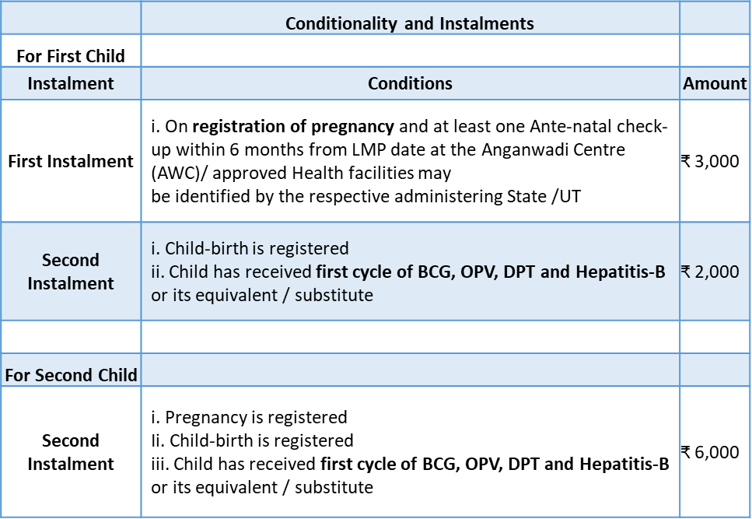
In case of miscarriage or stillbirth, the beneficiary will be treated as a fresh beneficiary for any future pregnancy.
An eligible beneficiary can apply for the benefit within 270 days from the child birth.
If a beneficiary delivers twins/ triplets/ quadruplets in her second pregnancy, and one or more of the children is a girl, she will receive incentive the incentive for the second girl child as per PMMVY 2.0 norms.

1.5 Workflows and roles of state, district, and block officials
The PMMVY portal supports five key workflows to ensure that all eligible beneficiaries are registered and payments are processed on time.
All workflows follow a 3 -step process of
“THE MAKER” >>> “THE CHECKER” >>> “THE APPROVER”

- Beneficiary registration:
Purpose: To onboard an eligible pregnant woman into the PMMVY system.
Output: Once approved, the beneficiary becomes eligible for first instalment (subject to conditionalities).
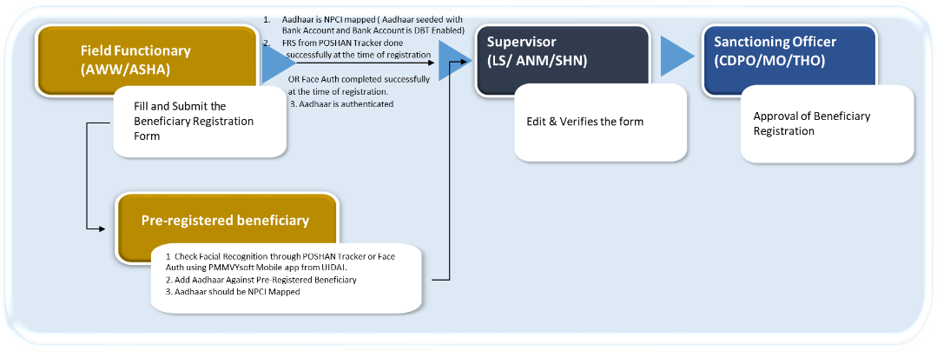

- Child-birth and immunization:
Purpose: To validate service delivery milestones required for instalment eligibility.
Output: Instalment is triggered for payment processing.

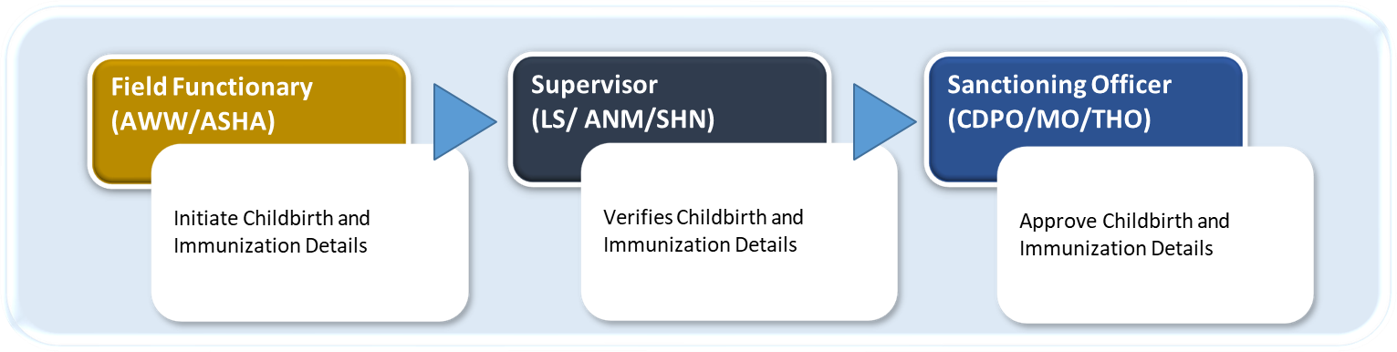

- Case Closure:
Purpose: To formally close a beneficiary case.
Triggers for Closure:
- All instalments paid successfully
- Beneficiary marked ineligible
- Duplicate case identified
- Special conditions (migration, death, etc.)

Output: The Case moves to the Closed/Completed list and is locked for further edits.

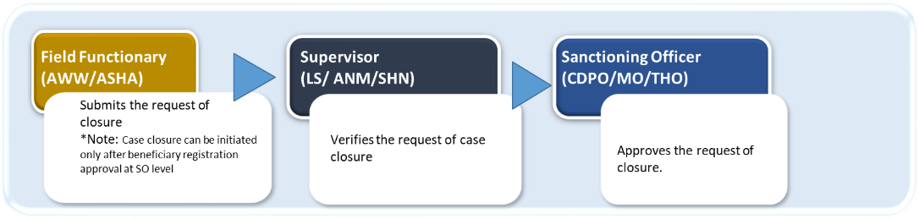

- Payment:
Purpose: To transfer the instalment amount to beneficiary.
Process Flow: CDPO generates the payment.

Output: Amount is credited to the beneficiary’s bank account.

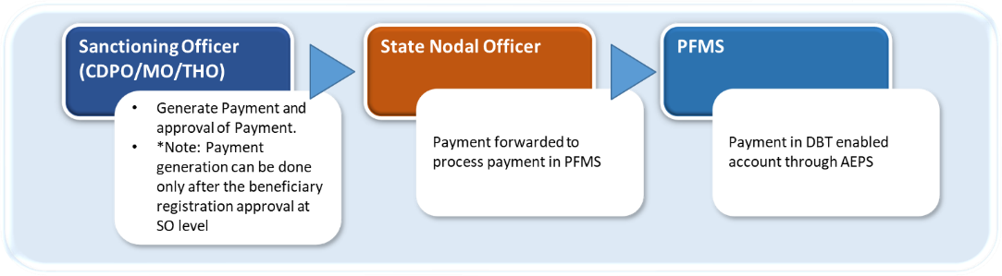

- User Management:
Purpose: To manage system access and role-based permissions.
Process Flow:
- User creation request initiated
- Role assigned (with defined permissions)
- Account activation by higher authority
- Password generation orreset
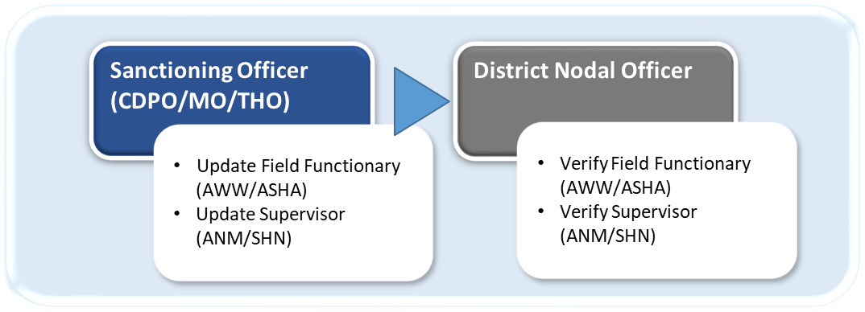
- Role modification or deactivation in case of transferred or retirement

1.6 PMMVY Soft
The PMMVYsoft MIS portal was launched to ensure that services are delivered directly through Anganwadi workers andASHAs in a paperless and efficient manner.
The portal includes several new features that support evaluation, analysis and monitoring of the scheme in an effective way. It has significantly simplified the application process and improved accessibility through mobile application for field functionaries (AWW/ASHA) and supervisor (Lady supervisor/ANM/SHN).
The system has been developed by National Informatics Centre (NIC).
Using the mobile application, registration and verification of the eligible beneficiaries can be done during home visit.
Website link: https://pmmvy.wcd.gov.in/
Download mobile app: https://pmmvy.wcd.gov.in/apk/PMMVYsoft.apk
Download mobile app from Google Playstore: https://play.google.com/store/apps/details?id=com.mission_shakti.pmmvy_application&hl=en_IN
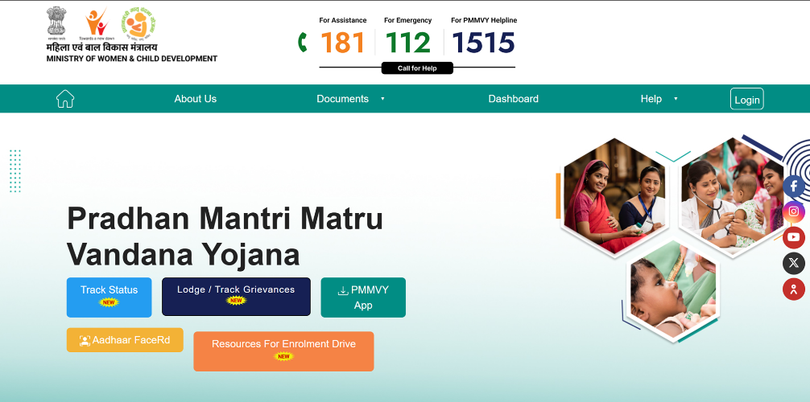

Key features of PMMVY:
- Integrated System: PMMVYsoft MIS integrates with multiple systems including LGD, UIDAI, PRAYAS, PFMS, NPCI, NIC-email service, NIC-SMS service etc.
- Integration with Public Financial Management System (PFMS): Enables online DBT payments through PFMS into beneficiary bank accounts using AEPS mode.
- Biometric Authentication: Supports Aadhaar authentication through facial recognition to facilitate the beneficiary verification process.
- Integration with National Payments Corporation of India (NPCI) Aadhaar lookup service: Helps verify whether Aadhaar is seeded in the beneficiary’s bank account and whether the account is DBT enabled.
- Mobile App for Field Functionary and Supervisor: Provides instant and user-friendly access to the portal to enable registration and verification during home visits.
- Real-Time Aadhaar authentication: Integration with UIDAI enables real-time Aadhaar authentication during registration.
- Accuracy through Supervision: ASupervisor verification layer ensures correctness of the information entered.
- Analytics & Reporting: Provides comprehensive and drill-down reports across administrative levels:
Location-wise (State -> District -> Block/ULB -> Village/Ward) and
WCD Hierarchy-wise (State -> District -> Project -> Sector -> Anganwadi Centre)
- Document Upload: Allows upload of eligibility documents as per the new Mission Shakti guidelines.
Key functionalities of PMMVY soft MIS
- Registers beneficiaries
- Captures childbirth and immunization
- Initiates payment generation and approval
- Case closure
- Ensures payment cycle is complete
- Search and Track Application
- Helpline
- Analytical dashboards
- Grievance redressal system

How to login into PMMVY soft? (Add youtube link)
1. Enter the USER ID in the text box labelled “USER ID”,
2. Enter the password in the text box labelled“Password”
3. Enter the OTP.
4. Click “LOG IN” button after entering all the details.
Stakeholder Login Types
There are 6 types of stakeholder logins available:
1. Central Nodal Officer
2. State Nodal Officer
3. District Nodal Officer
4. Sanctioning Officer (CDPO/MO/THO)
5. Supervisor (Lady supervisor/ANM/SHN)
6. Field functionary (AWW/ASHA)

How to change password?
https://www.youtube.com/watch?v=wKfGt4zHJyM&list=PLcE8_LFPUizhR3KnUGY6I3BoK98yuct4A&index=12

